Azure key Vault
AWS vs Azure
AWS Secrets Manager
≈
Azure Key Vault (Secrets)
Both are used to store:
Passwords
API Keys
Connection Strings
Tokens
Certificates

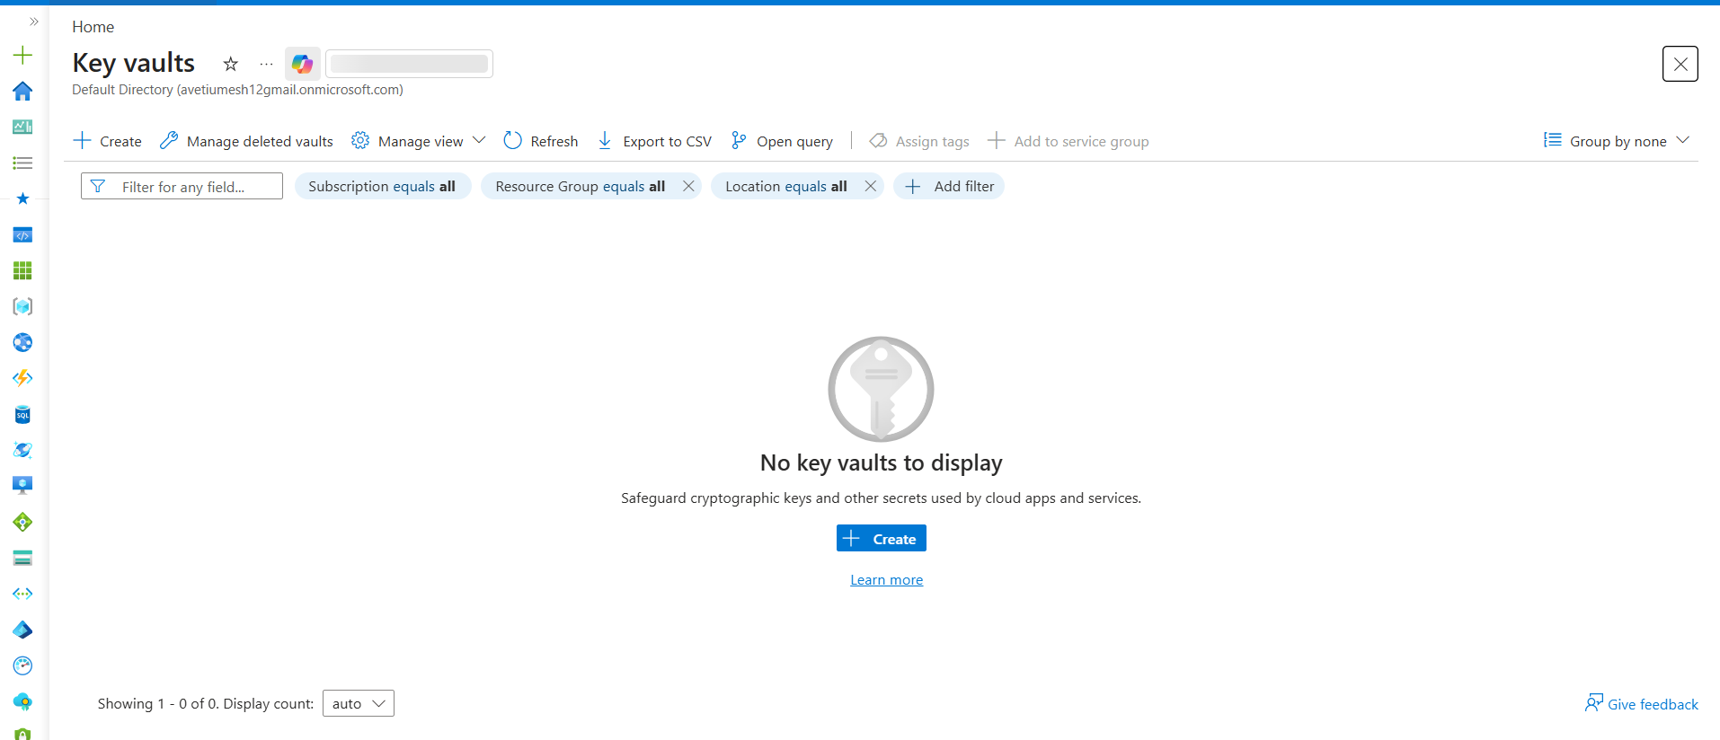

Azure Key Vault Stores 3 Things
1. Secrets
2. Keys
3. Certificates
Secrets
Database Password
API Token
Connection String
Similar to AWS Secrets Manager.
Keys
Encryption Keys
Similar to AWS KMS.
Certificates
SSL/TLS Certificates
Can store and manage certificates.

AWS Comparison
AWS Secrets Manager
+
AWS KMS
+
Certificate Management
≈
Azure Key Vault
Real DevOps Example
Instead of storing:
DB_PASSWORD=Admin123
inside:
Pipeline
Terraform
VM
Application
store it in:
Azure Key Vault
Then:
VM
↓
Managed Identity
↓
Key Vault
↓
Get Secret
No password is hardcoded.

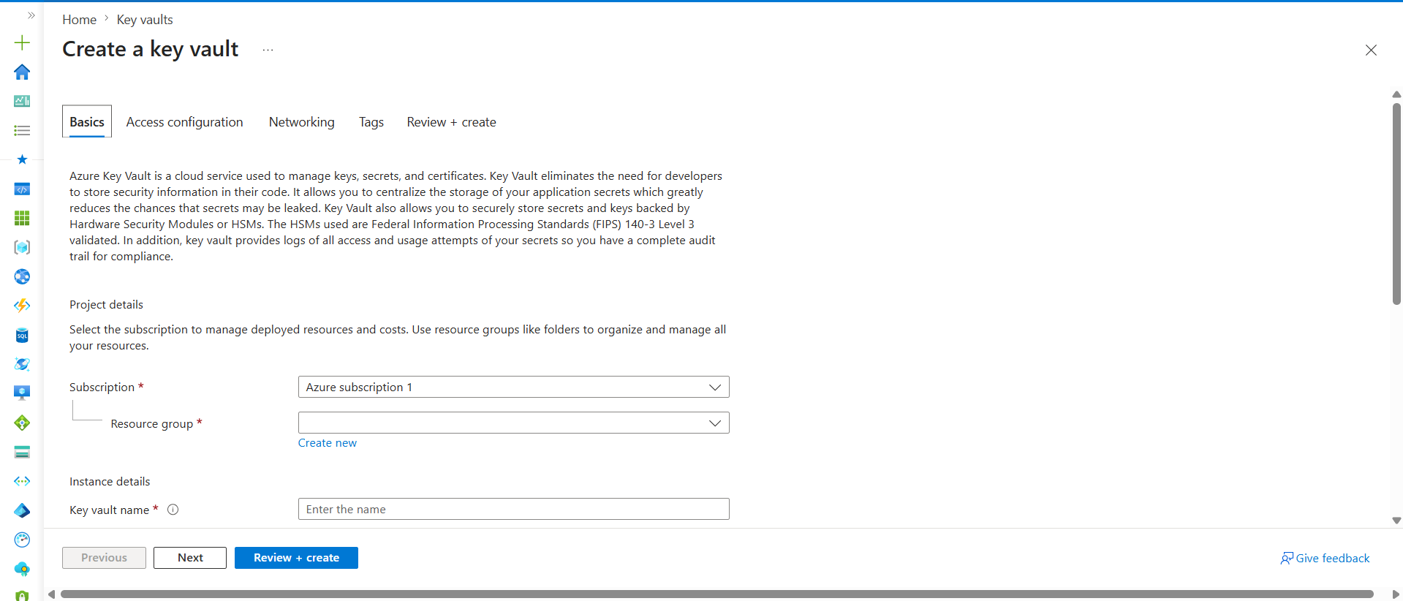
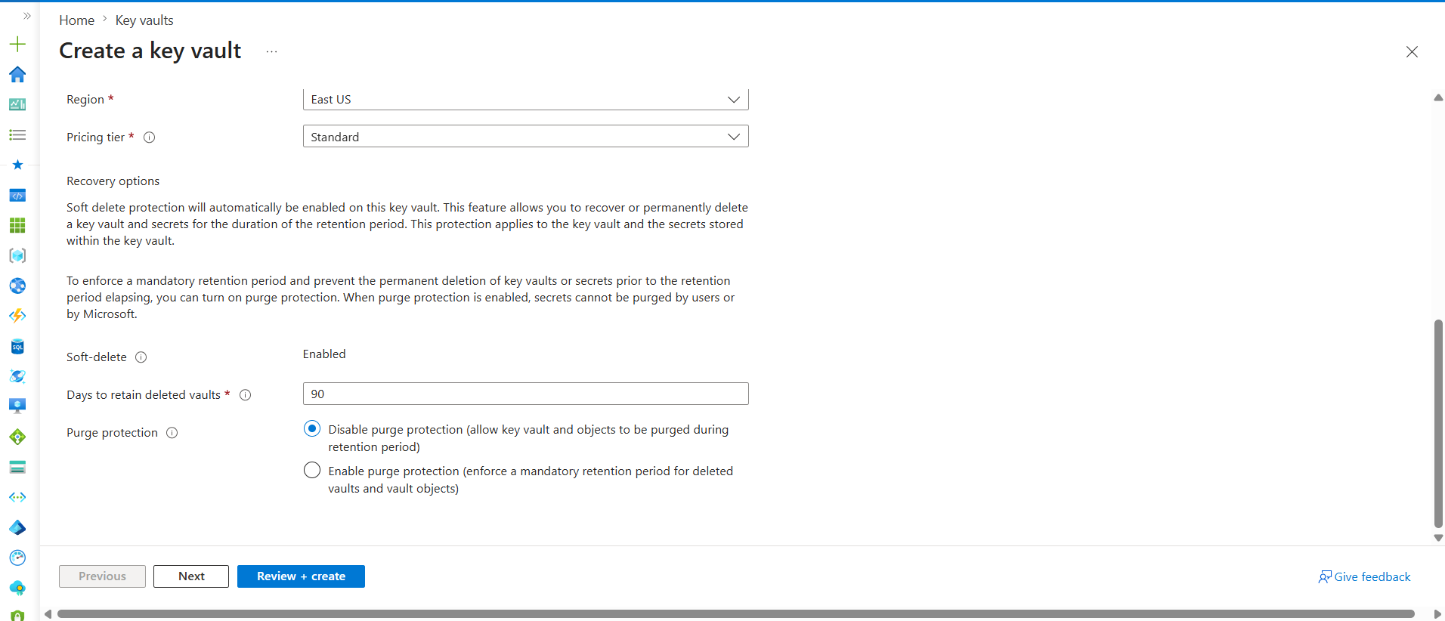
Resource Group
Definition: A logical container that holds related Azure resources.
Usage: Used to manage, monitor, and apply RBAC permissions to multiple resources together.
If not used properly: Resources become difficult to organize and manage individually.
Example: One Resource Group containing VM, Storage Account, AKS, and Key Vault.
Key Vault Name
Definition: A unique identifier for the Key Vault in Azure.
Usage: Used to locate and access the vault that stores secrets, keys, and certificates.
If not provided: Azure cannot create or identify the Key Vault.
Example: devops-kv-prod or umesh-keyvault.
Region
Definition: The Azure datacenter location where the Key Vault is deployed.
Usage: Helps keep resources close to applications for better performance.
If chosen incorrectly: Applications may experience higher latency when accessing secrets.
Example: East US, Central India, West Europe.
Pricing Tier
Definition: Determines the capabilities and security features available in the Key Vault.
Usage: Standard is used for most workloads, while Premium supports HSM-backed keys.
If wrong tier is selected: Required security or compliance features may be unavailable.
Example: Standard for DevOps projects, Premium for banking applications.
Soft Delete
Definition: A feature that allows recovery of deleted vaults and secrets.
Usage: Protects against accidental deletion of important secrets and keys.
If disabled: Deleted secrets may be permanently lost.
Example: Recover a deleted database password within the retention period.
Days to Retain Deleted Vaults
Definition: The number of days deleted vaults and secrets remain recoverable.
Usage: Provides a recovery window before permanent removal.
If set too low: Recovery may not be possible after the retention period expires.
Example: 90-day recovery period for deleted secrets.
Purge Protection
Definition: Prevents permanent deletion of vaults and secrets before retention expires.
Usage: Adds protection against accidental or malicious deletion.
If disabled: An administrator can permanently purge deleted data immediately.
Example: A deleted secret cannot be permanently removed until the retention period ends.

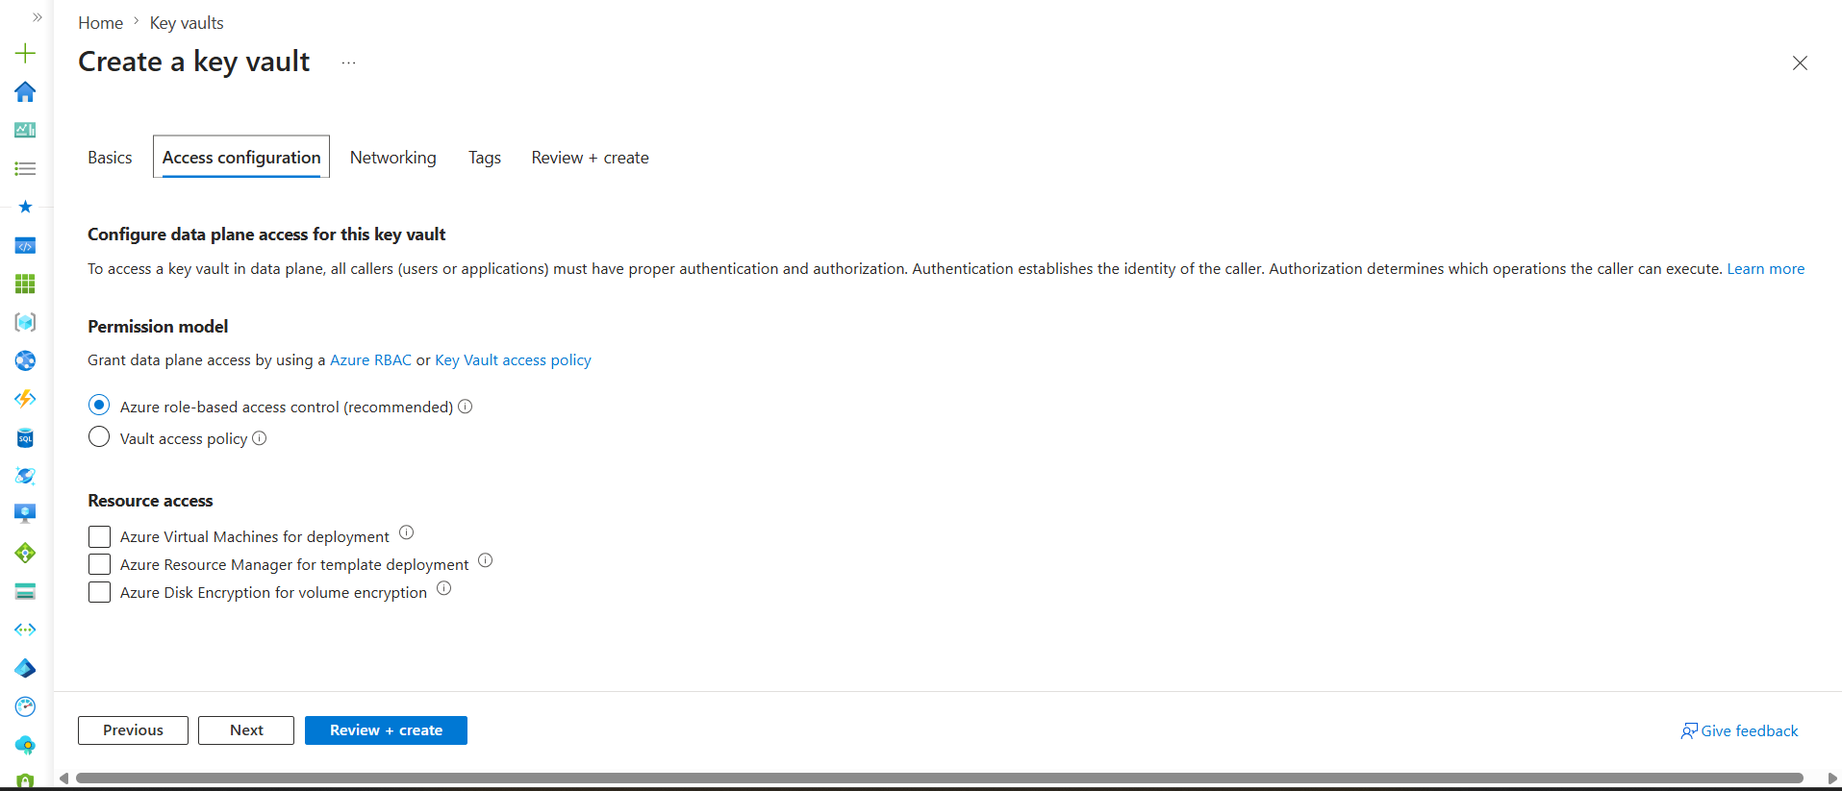

Azure Role-Based Access Control (Recommended)
Definition: Uses Azure RBAC roles to control who can access secrets, keys, and certificates in Key Vault.
Usage: Assign roles such as Key Vault Secrets User, Key Vault Administrator, or Reader to Users, Groups, Service Principals, or Managed Identities.
If Not Used: You must manage permissions separately using Key Vault-specific access policies.

Example:
VM Managed Identity
↓
Key Vault Secrets User
↓
Key Vault
VM can read secrets from Key Vault.

Vault Access Policy
Definition: Legacy permission model used specifically for Key Vault access management.
Usage: Directly grant permissions like Get, List, Create, Delete on secrets, keys, and certificates.
If Used: Permissions are managed separately from Azure RBAC, increasing administration effort.
Example:
User
↓
Access Policy
↓
Get Secret Permission
↓
Key Vault
Azure Virtual Machines for Deployment
Definition: Allows Azure VMs to retrieve certificates and secrets during deployment.
Usage: Used when VM provisioning requires certificates or secrets from Key Vault.
If Not Enabled: VMs cannot automatically fetch those secrets during deployment.
Example:
VM Creation
↓
Get SSL Certificate
↓
Key Vault

Azure Resource Manager for Template Deployment
Definition: Allows ARM templates and deployments to access secrets stored in Key Vault.
Usage: Used when Infrastructure as Code deployments require passwords or connection strings.
If Not Enabled: ARM templates cannot retrieve secrets from Key Vault.
Example:
ARM Template
↓
Get Admin Password
↓
Key Vault

Azure Disk Encryption for Volume Encryption
Definition: Allows Azure Disk Encryption to use keys stored in Key Vault.
Usage: Used to encrypt VM operating system and data disks.
If Not Enabled: Azure Disk Encryption cannot use Key Vault-managed keys.
Example:
VM Disk
↓
Encryption Key
↓
Key Vault

For a DevOps Engineer
For most modern projects:
Select:
✅ Azure Role-Based Access Control (RBAC)
Leave unchecked:
❌ VM Deployment
❌ ARM Template Deployment
❌ Disk Encryption

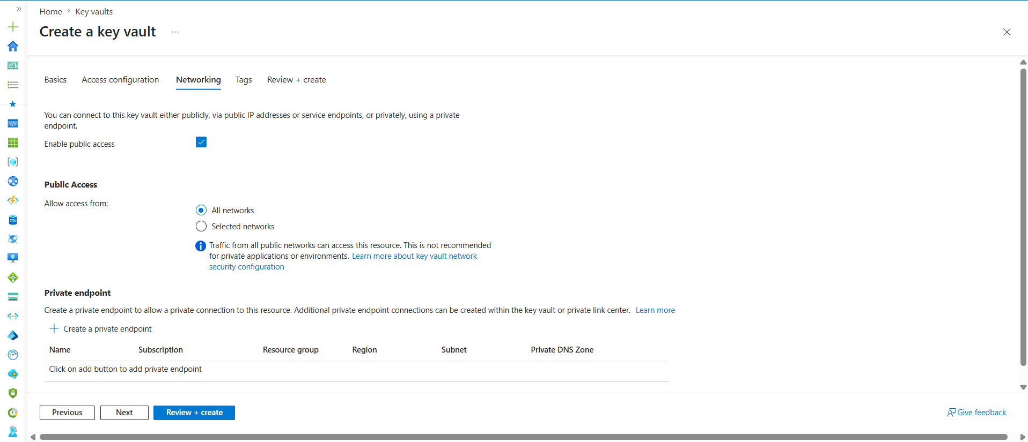

Enable Public Access
Definition: Controls whether the Key Vault can be accessed through public internet endpoints.
Usage: Used to allow applications, users, or services to connect to Key Vault over the internet.
If Disabled: Only private endpoint connections can access the Key Vault.
Example: A developer accessing Key Vault from a laptop over the internet.

All Networks
Definition: Allows access from any network that can reach the Key Vault endpoint.
Usage: Common in labs, testing, and learning environments.
If Used in Production: Increases security risk because anyone on the internet can attempt to connect.
Example: Any VM, laptop, or application can reach the Key Vault URL.

Selected Networks
Definition: Restricts Key Vault access to specific VNets, subnets, or IP addresses.
Usage: Used in enterprise environments for tighter security.
If Not Configured Properly: Legitimate applications may be unable to access secrets.
Example: Only AKS cluster subnet and corporate office IPs can access Key Vault.

Private Endpoint
Definition: Creates a private connection between Azure resources and Key Vault using a private IP.
Usage: Keeps traffic inside the Azure network without using the public internet.
If Not Used: Traffic may travel through public endpoints even if encrypted.
Example: AKS → Private Endpoint → Key Vault.

Subscription
Definition: The Azure subscription where the Private Endpoint resource will be created.
Usage: Used for billing and resource ownership.
If Incorrect: Private Endpoint may be created in the wrong environment.
Example: Azure Subscription 1.

Resource Group
Definition: The Resource Group where the Private Endpoint resource is stored.
Usage: Helps organize networking resources.
If Incorrect: Network resources become difficult to manage.
Example: Networking-RG.

Region
Definition: The Azure region where the Private Endpoint is deployed.
Usage: Usually matches the Key Vault and application region.
If Different: Network latency may increase.
Example: East US.

Subnet
Definition: A subnet inside a VNet where the Private Endpoint receives a private IP.
Usage: Enables Azure resources in that subnet to privately access Key Vault.
If Missing: Private Endpoint cannot be created.
Example: AKS-Subnet or VM-Subnet.

Private DNS Zone
Definition: Resolves the Key Vault name to its private IP address.
Usage: Allows applications to use the normal Key Vault URL while privately connecting.
If Not Configured: Name resolution may fail even though the endpoint exists.
Example:
devops-kv.vault.azure.net
↓
10.0.1.5 (Private IP)

Real-World DevOps Setup
Developer Learning Lab
↓
Enable Public Access
↓
All Networks
Production Environment
↓
Disable Public Access
↓
Private Endpoint
↓
VNet + Subnet + Private DNS

Key Vault created
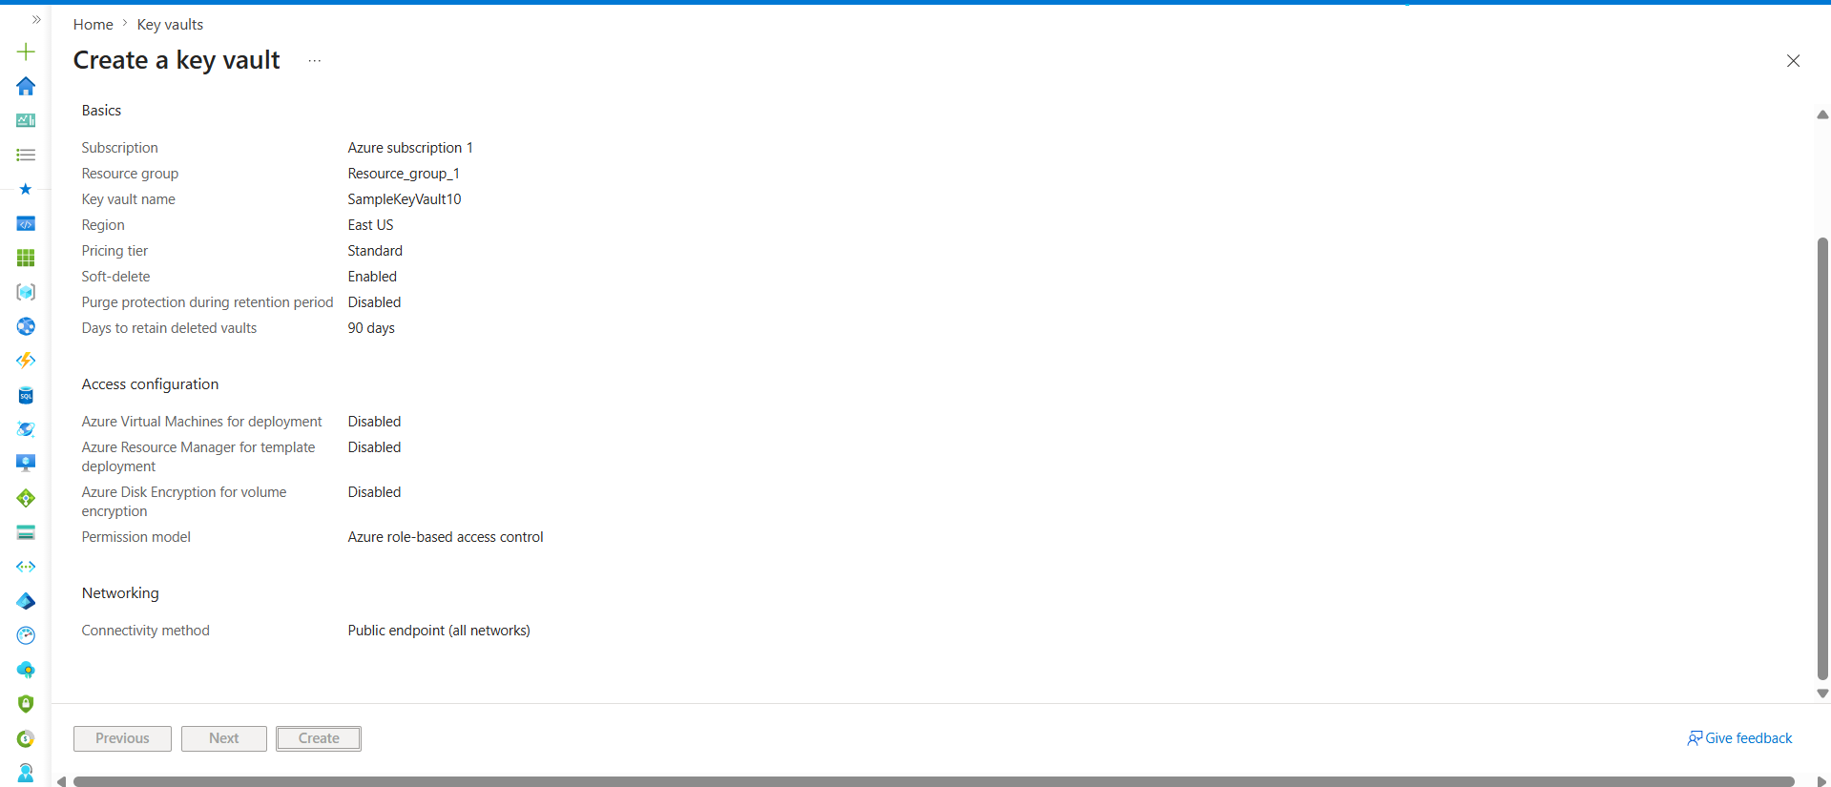

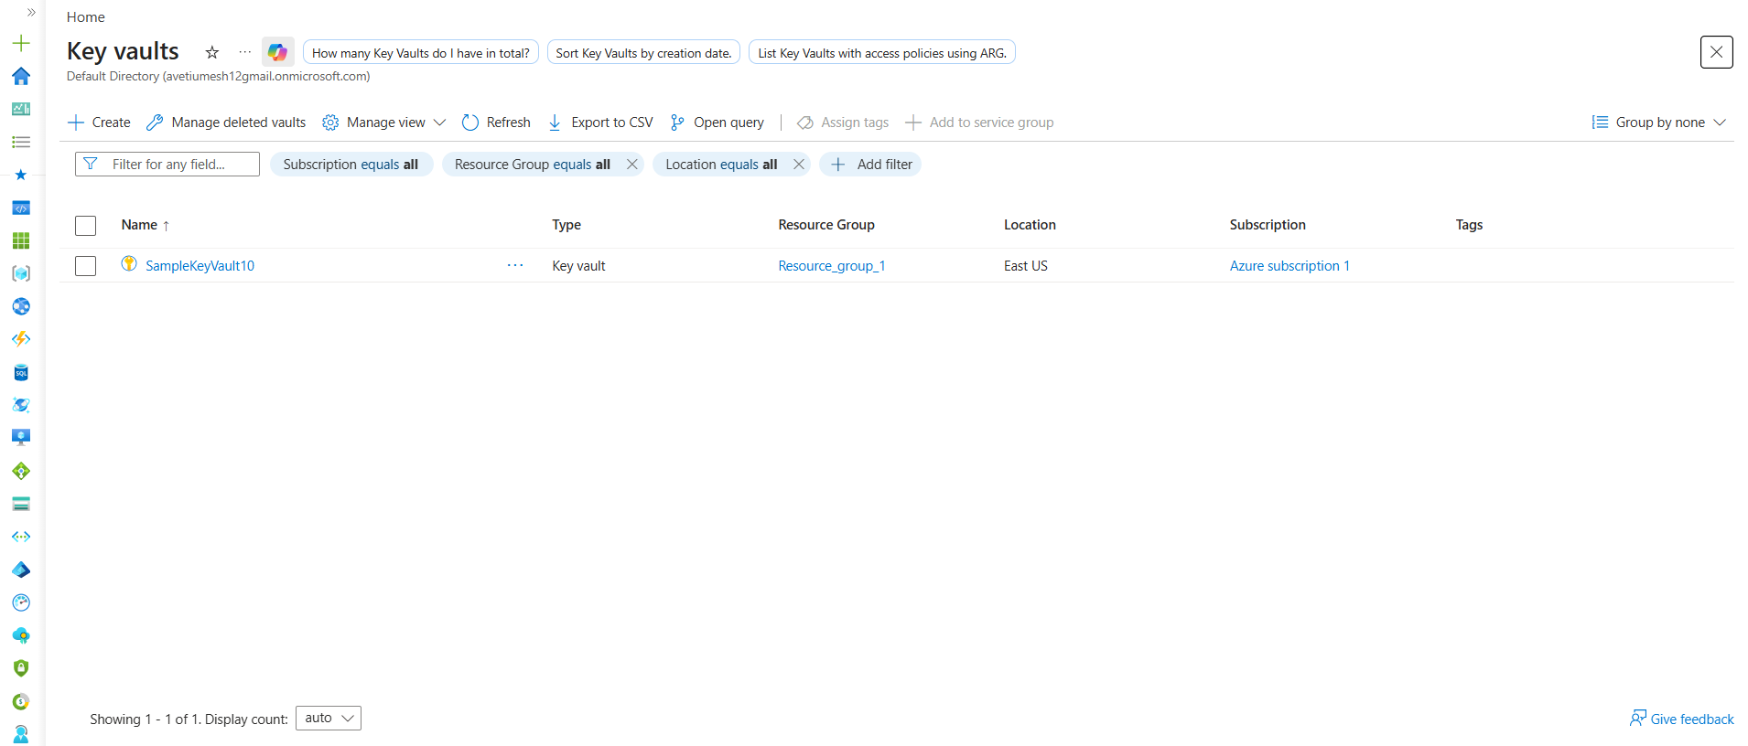

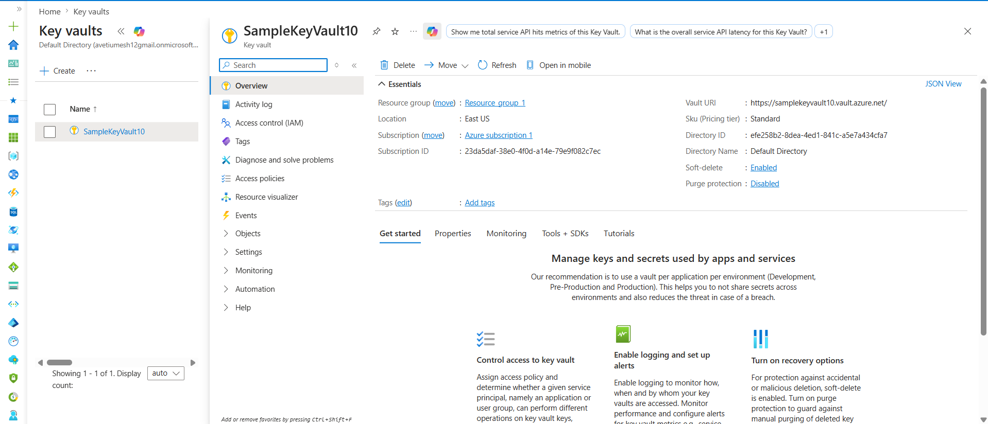
Now look at the left menu. The most important thing for learning is:
Objects
├── Keys
├── Secrets
└── Certificates
This is where the actual data gets stored.
What each one stores?
Secrets
Definition: Stores sensitive values as plain secrets.
Usage: Passwords, API Keys, Tokens, Connection Strings.
Example:
DB_PASSWORD = MyPassword123
GITHUB_TOKEN = ghp_xxxxx

Keys
Definition: Stores cryptographic encryption keys.
Usage: Encrypting and decrypting data.
Example:
AES Key
RSA Key

Certificates
Definition: Stores SSL/TLS certificates.
Usage: Secure HTTPS communication.
Example:
company.com SSL certificate
api.company.com certificate

Real DevOps Usage
Most DevOps engineers use:
90% → Secrets
8% → Certificates
2% → Keys
because applications usually need:
Database Password
API Key
Storage Account Key
GitHub Token
Docker Registry Password

